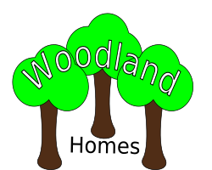

The Spinney

Greenlands

Foreston

Barkshire

FF2 9OF

0115-496 0377

07:September:2021

Dr. Anderson

63 Hampton Court Rd

SOUTHWICK

PE8 9LJ

Dear Caitlin,

Thank you for your interest in Woodland Homes.

We regret there are no single apartments available at the moment.

Please ring the office to arrange a viewing.

Regards,

Name Surname, XXXXX, XXXX



The Spinney

Greenlands

Foreston

Barkshire

FF2 9OF

0115-496 0377

07:September:2021

Mr. Patel

85 Iolaire Road

NEW MILTON

BH25 6GY

Dear Harvey,

Thank you for your interest in Woodland Homes.

We have one vacancy for a double apartment in Ash House.

Please ring the office to arrange a viewing.

Regards,

Name Surname, XXXXX, XXXX



The Spinney

Greenlands

Foreston

Barkshire

FF2 9OF

0115-496 0377

07:September:2021

Ms. Gardner

91 Circle Way

CAIRNORRIE

AB41 8RJ

Dear Emily,

Thank you for your interest in Woodland Homes.

We regret there are no single apartments available at the moment.

Please ring the office to arrange a viewing.

Regards,

Name Surname, XXXXX, XXXX